**Visualisation:**

**Confirmed Cases Line Graph:**

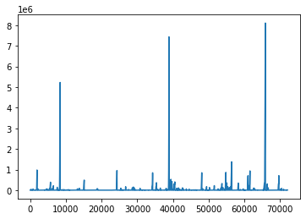

**Total Cases Line Graph:**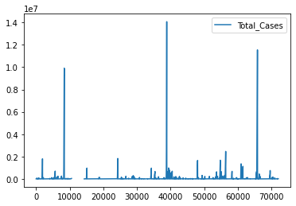

**Death Cases Line Graph:**

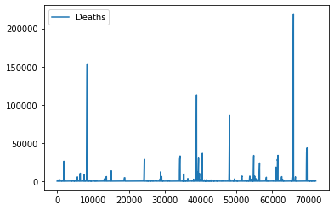

**Bar Graph:**

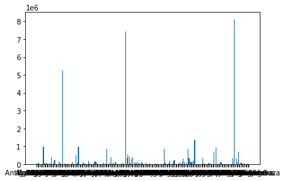**Bar**

**Pivot Table Graph:**Here, columns are filled with **Dates**, Rows are **Country/Region** and the values are filled with **Confirmed Cases**.

